
Thank you for expressing an interest in signing up to the whatimpact platform.
We have developed a template of our Social Enterprise to give you an idea of the information you will need to fully complete your online profile.
This document is a preparatory tool. When you are ready, copy and paste your collected data into the online profile to speed up your account activation process.

First you will be asked whether you would like to create a new profile or be added to an existing profile as an admin.

If you select the admin option someone else from your organization will have to add you.

If you select new profile, you will then be asked to select which profile type you want to create, in this case you are going to choose Unregistered group.
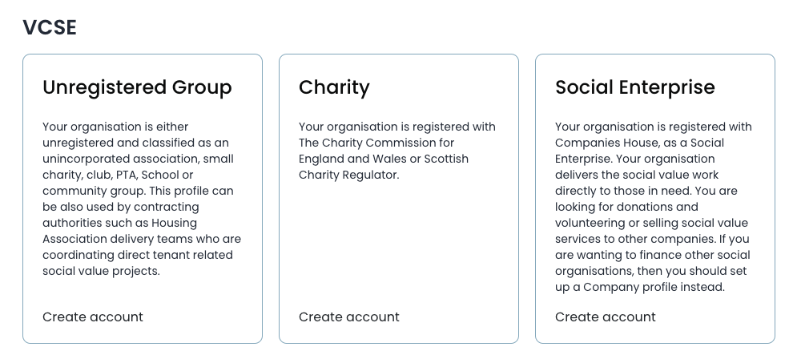

Sign Up

Email:
Password:
Full Name:

On the live site, we recommend that you use the main sign-up portal, rather than the Google option.

Create a whatimpact account.

Step one: Create Profile

Core profile.
This section contains all the information about your group

Pop-up information bubbles will guide you through the process of creating your account.

Organisation details

Trading name (This is your charity trading name. It may be the same as your registered name):

Registered name (This is your organisation name, registered with the Companies House):

Organisation type:
Public Limited Company - PLC / Private Limited Company by share / Private Unlimited Company / Private Limited Company by guarantee / Community Interest Company (CIC) / European Economic Interest Groupings - GP04 / Limited Liability Partnership / Limited Partnership / European Public Businesses / International Companies / Social Enterprise / Other

Organisation number (This is your Company House Registration number):

Year of Registration:
(DD/MM/YYYY)

Companies house URL:

Your logo
File should be min 800px x 800px, JPG and not more than 10MB.

Key image:
File should preferably be 1920px x 1080px, JPG, PNG and not more than 10MB.
Tagline (80): A short catchphrase or slogan that indicates your charity goal. Make sure your tag line includes buzzwords to connect you to the right match.

Your Company

Brief History (350 characters): Please give a brief history of your operation.

Vision for a better future (350 characters): What is the future world your organisation wishes to build?

Number of shops attached to your organisation (if applicable):

Your goals to make a difference (you must have at least 2 goals) (160 characters each).
Measurable short- and longer-term progress caused by your activity and work.

Your cause and area of interest (Choose one or multiple examples of the cause your charity is working to support):
- Abuse
- Agriculture
- Animal welfare
- Arts & culture
- Boys & Men
- Carer support
- Climate change
- Community
- Covid-19 recovery
- Crime and rehabilitation
- Disorders
- Diversity & inclusion
- Education
- Elderly
- Employment
- Environment
- Equal Opportunity
- Food & Hunger
- Girls & Women
- Health & Wellbeing
- Heritage & History
- Housing
- Human Rights
- Mental Health
- Military & Public Services
- Poverty
- Recycling
- Religion
- Rescue & Disaster
- Sanitation
- Schools, Disability
- Sports & Recreation
- Village Halls
- Waste
- Water
- Wildlife
- Youth & Young Adult

Your reach
Beneficiaries- who or what will benefit from your work?

- Children/young adults.
- Elderly/old people
- People of particular ethnic/racial backgrounds
- Adults
- Other charities or voluntary bodies
- The general public/mankind
- Nature
- Animals

Please describe more specifically who your beneficiaries are and how you work with them. Specific description (for each beneficiary): (250 characters each):

Please define your geographic areas of activity (Drop down list of options You’ll be able to choose one or multiple examples):

Country of operation:

Specific geographical focus area:

Testimonials:
Partner testimonial
Please provide a testimonial from a partner. (250 characters)

Who said this?

Who do they work for?

Logo: File should be min 400px x 400px, JPG or PNG and not more than 10M

Beneficiary testimonial:

Please provide a testimonial from a project beneficiary or client that you have served. If the work that you do is sensitive, please use 'Anonymous'. (250 characters)

Who said this?

Who do they work for?

Logo: File should be min 400px x 400px, JPG or PNG and not more than 10MB

Our Social Value in media:
Promote the news, articles or blog posts that your social value work has been featured in. This is a great opportunity for your stakeholders, partners or the general public to stay up to date with your latest news.

Name of piece:

Provider:

Description (60 characters):

Date published:
(DD/MM/YYYY)

Info Link:

Logo: File should be min 400px x 400px, JPG or PNG and not more than 10MB

Step 2: How to help
Use this section to list ways that whatimpact members or the general public can support your work. Ask for the money, services, products, or skilled volunteers you seek.

Money:
- Donate
- Fundraise
- Leave a gift in your will
- Restricted grants
- Unrestricted grants

Description (40 characters for each option selected):

Skilled Volunteers
Utilise skilled volunteers, with knowledge and expertise, specific to your organisation's needs

Options:
- Administrative
- Arts & Culture
- Befriending
- Construction & Manual Labour
- Education/Coaching
- Finance
- Fundraising
- Health Care
- HR,
- Innovation
- IT
- Legal,
- Logistics
- Marketing
- Mixed Skills Project
- Operations Management
- Other
- property Management

Description (For each Skilled volunteering type you need) (40 characters)

Products- Does your organisation need any product donations? These could be water bottles, books, IT equipment etc. Include links to activities that would benefit from products and resources.

Options:
- Animals, Baby & Child
- Clothing & Footwear
- Construction & Building
- Disability, Electronics
- Free Tickets
- Groceries & Toiletries
- House & Garden
- Medical
- Sport & Leisure
- Transport

Description (For each product type you need) (40 characters)

Services- Does your organisation need any service donations? Services could include: pro bono professional work (legal, web, business strategy, design etc), as well as free membership to your programme, a free licence to software.

Service donation request:
- Cleaning
- Construction support/manual labour
- Decorating and maintenance
- Equality and diversity training
- Finance
- Fundraising
- Gardening
- Healthcare/medial
- IT/tech
- Legal
- Media/marketing
- Property/venues

Description (For each service donation type you need) (40 characters)

More ways to help- Describe and other ways to support your organisation (500 characters):

Buy from us- Please describe any products or services you have for sale.

This is a space to promote your organisation’s products or services, so that companies or individuals can support your activity. This could be your organisation's branded merchandise, venue space or training courses. You can add multiple options on the live site. (350 characters)

Link option: https://
Add an image: File should preferably be 1920px x 1080px, JPG or PNG and not more than 10MB

Step 3: Financials & Diligence- Information on your financial status encourages transparency and trust, leading to more successful collaborations.

Financials

Paste the link to your profile on Companies House:

Key Figures

Please define your fiscal year:
Date from (DD/MM/YYYY)
Date to (DD/MM/YYYY)
Annual turnover: £………

Please define your workforce:

Number of volunteers:
Number of employees:

Key People

Leadership responsibility for this group:
*connecting linkedin profiles will enhance credibility over just having names

Per key person:
Name:
Title/role:
Linkedin Profile:

Annual Report
Please upload your annual report: Max uploaded file size is 10MB in PDF format.

Link to our 360 Giving Profile:
If your charity has received a grant or grants from any grant maker listed on 360Giving grant database, please visit http://grantnav.threesixtygiving.org/recipients and copy paste your charity profile link here to demonstrate the grants you´ve received in the past.

https://

Step 4: Contact details.

Your website: https://

Primary email:

Telephone (incl area code):

Your Address:
Address Line 1:
Address Line 2:
Country:
Postcode:

Social Media:
- Facebook
- LinkedIn
- Twitter
- Youtube
- Instagram

Add a reference link for each:

Step 5: Create a project
To apply for resources, you must have at least one activity published on your profile. You can publish as many activities as you like. Activities are the most important parts of your application, so please provide as many details as you can. These details will be automatically included in your social impact reporting. When you are ready, publish your activity in order to start the matching process and receive offers.

Project Overview

Project details

Project name:

Short description (500 characters)

Project size per annum: £……….

Resources Needed For the Project:
Select Resources from the options:

- Money
- Products
- Services
- Skills
- Non-Skilled Volunteering

Description (120 characters):

Quantity needed (120 characters):

When needed:
Flexible OR by a certain date?

How this donation supports the project (enabling actions or KPIs) (120 characters):

Project Beneficiaries:
Who will benefit from this project?

- Children/Young people
- Elderly/Old people
- People of particular ethnic/racial backgrounds
- Adults
- Other charities or voluntary bodies
- The general public/mankind
- Nature
- Animals

Please provide any specific details (250 characters each)

Total beneficiaries:
Approximately how many beneficiaries or targets do you aim to reach? Only complete this section if you have beneficiary targets for your overall target:

How would you categorise your beneficiaries or reach?:
Number of beneficiaries [ ]
Reach of work [ ]

How many beneficiaries or targets do you aim to reach in the overall project?

Please provide any further comments (60 characters):

Annual beneficiaries
How would you categorise your beneficiaries or reach?

- Children/Young people
- Elderly/Old people
- People of particular ethnic/racial backgrounds
- Adults
- Other charities or voluntary bodies
- The general public/mankind
- Nature
- Animals

How many beneficiaries or targets do you aim to reach annually?

Please provide any further comments (60 characters):

Project timeline

Start date: xx/xx/xxxx
End date: xx/xx/xxxx
Ongoing:

Your reporting periods on whatimpact:

Quarterly:
Bi- Annually:

Criteria:
Choose framework:
- TOM System™

Themes:
- x4Work
- Economy
- Community
- Planet
- None of the listed

Outcomes: select from options

Measures: select from options

Project Outcome Targets

Please enter up to 3 goals:
These are the outcomes that you are trying to achieve. Either describe the change that you wish to create or quantify them. (100 characters each):

Project activities

Please enter up to 5 project activities:
How are you actively engaging with your reach? What are you practically doing to instigate change? (100 characters each):

Please describe how you monitor the quality of your work (100 characters):

UN Sustainable Development Goals (SDG):
Please select the UN SDGs that align with with this project:

- UN SDG 1: No Poverty
- UN SDG 2: Zero Hunger
- UN SDG 3: Good Health and Well-being
- UN SDG 4: Quality Education
- UN SDG 5: Gender Equality
- UN SDG 6: Clean Water and Sanitation
- UN SDG 7: Affordable and Clean Energy

Geographic reach of the activity
You can choose multiple locations. Dropdown list.

Country of operation:

Region of operation:

Who is already funding this activity?

Name:

Please add a description (100 characters)

Please add a link to their website: https://

Other partners

Name

More details (100 characters)

Please add a link to their website: https://

Thank you for completing your whatimpact profile template. You are all ready to go!
Once your profile goes live, you’ll be able to find supporters that have automatically matched to your profile, start applications for exciting opportunities, check your inbox, talk directly through our communication channel, and use settings to keep your account up to date.

whatimpact team

